**Gujarat Technological University**

**Chandkheda, Ahmedabad**

**Affiliated**

**Vishwakarma Government Engineering College**

A

Project Report

On

**Drunk driving detection**

Under Subject of

**Design Engineering-IIA**

B.E. II, Semester IV

EC Branch

Submitted by:

**S r. No. Name Enrollment No.**

**1** Rajgor Daivik 180170111089

**2** Vataliya Harsh 180170111120

**3** Shah Jainam 180170111100

**4** Sheikh Sadam 180170111105

**5** Rathva Harsh 180170111093

Prof JayeshDiwan

**Faculty Guide Head of the Department**

Academic year

2019-2020

**CANDIDATE’S DECLARATION**

We have finished our project report entitled”​**Drunk driving detection**” and submitted to our respective guide. We are in 3​rd semester and we have tried to give our best. We have done our work honestly and in a good way.

|  |  |  |
| --- | --- | --- |
|  | : ​**RajgorDaivik** |  |
| First Candidate’s Name |  |
| Branch | : ​**ECE** |  |
| Enrollment No. | : ​​ **180170111089** |  |
|  |  |  |
| Second Candidate’s Name : ​**Vataliya Harsh** | |  |
| Branch | :​ **ECE** |  |
| Enrollment No. | : ​​​ **180170111120** |  |
|  |  |  |
| Third Candidate’s Name | **: Shah Jainam** |  |
| Branch | **: ECE** |  |
| Enrollment No. | **: 180170111100** |  |
|  |  |  |
| Fourth Candidate’s Name | **: Sheikh Sadam** |  |
| Branch | : **ECE** |  |
| Enrollment No. | : **180170111105** |  |

Fifth Candidate’s Name : **Rathva Harsh**

Branch : E**CE**

Enrollment No. : **180170111093**

Submitted to: Vishwakarma Government Engineering College, Ahmedabad.

Affiliated to:Gujarat technological university.

**ACKNOWLEDGEMENT**

We would like to extend our heartily thanks with a deep sense of gratitude and respect to all those who has provided us immense help and guidance during our project.

We would like to express our sincere thanks to our internal guide **(Prof.JayeshDiwan**) for providing a vision about the system and for giving us an opportunity to undertake such a great challenging and innovative work. We are grateful for the guidance, encouragement, understanding and insightful support given in the development process.

We would like to extend my gratitude to Head of Electronics and Communication Engineering Department, Vishwakarma Government college of Engineering and Technology, Ahmedabad, for his continuous encouragement and motivation.

Last but not the least we would like to mention here that we are greatly indebted to each and everybody who has been associated with our project at any stage but whose name does not find a place in this acknowledgement.

Yours Sincerely,

​​

RajgorDaivik (180170111089)

Vataliya Harsh (180170111120)

Shah Jainam. (180170111100)

Sheikh Sadam (180170111105)

Rathva Harsh (180170111093)

|  |  |  |
| --- | --- | --- |
| **Table of contents** | | |
| **Sr. No.** | **Title** | **Page** |
| **1.** | Title page | 01 |
| **2.** | Table of contents | 06 |
| **3.** | Abstract | 07 |
| **4.** | Introduction of Project | 07 |
| **5.** | **Canvas:** |  |
|  | 1. Empathy Canvas |  |
|  | 2. A.E.I.O.U Canvas | 17 |
|  | 3. Mind map Canvas | 18 |
|  | 4. Ideation canvas | 19 |
|  | 5. Product development Canvas | 20 |
| **6.** | Conclusion | 21 |

**Abstract**

The aim of our Project is to make human driving safer and to overcome accidents. This project is developed by integrating alcohol sensor with Arduino board. Arduino processor ATmega328 is able to handle more functions than conventional microcontrollers. The alcohol sensor used in this project is MQ3 which to detect the alcohol content in human breath. Since sensor has fine sensitivity range around 2 meters, it can suit to any vehicle and can easily be hidden from the suspects. This project is fitted inside the vehicle. The project is designed for the safety of people sitting inside the vehicle.

* 1. **INTRODUCTION**

Alcohol detectors are commonly required by the law enforcement. The police need to catch and check people who drive after taking alcohol. Driving after taking alcohol can result in serious accidents. People who drive after consuming alcohol not only risk their own life but also of others. That is why police need to remain alerted and verify any person who they found suspicious of driving after drinking. For the verification, they use an instrument called alcohol detector. This project is aimed at building a similar device which will detect the consumption of alcohol by a suspect and display a digital reading indicating the level of alcoholic consumption. The device will also have a dial which will rotate and an LED indicator which glows to indicate a dangerous level of consumption by a suspect.

The MQ-3 sensor is used in the project to detect alcohol level. The sensor detects the alcohol consumption by the smell of the breath. The sensor is an analog as well as a digital sensor which on its analog pin outputs the analog voltage proportional to the alcohol level. The project is built on Arduino Pro Mini as the device is designed to be a handheld device. Apart from the MQ-3 sensor, a servo motor and an LED is also interfaced to the controller board to move the dial and indicate a dangerous level of consumption through LED indication. The reading taken by the sensor is displayed on a 16X2 character LCD.

The Arduino sketch manages to take the reading from the MQ-3 sensor, digitize and display reading, compare reading with a threshold level and operate LED as well as Servo to indicate a dangerous level of consumption. The Arduino code is written on Arduino IDE and burnt to the Pro Mini using the same.

* 1. **PROBLEM STATEMENT**

Drunken driving is considered as one of the major reason of accidents in worldwide. Drivers under the influence of alcohol shows a clear failure of perception recognition and vehicle control. So, by this accident occurs.

* 1. **PROPOSED SYSTEM**

Alcohol detection in vehicle system is continuously growing over years which could resolve drunken driving accidents worldwide.

* 1. **HARDWARE MODULES**



* 1. **Components Required**

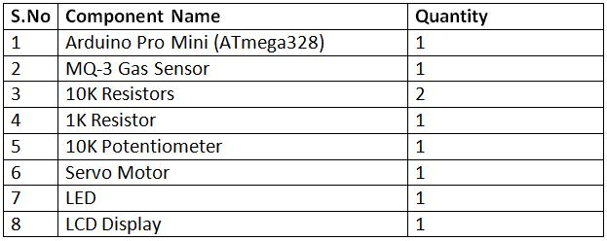

1. **ARDUINO BOARD**

The arduino board is the central unit of the system. The arduino uno is the microcontroller board based on the ATmega 328. It is a programmable microcontroller for prototyping electromechanical devices.it has 14 digital inputs/output pins (of which 6 can be used as PWM output),6 analog inputs , a 16 MHz ceramic resonators the arduino differs from all preceding board is that it does not use the FTDI USB to serial driver chip.



**2. ALCOHOL SENSOR (MQ3)**

The analog gas sensor- MQ3 is suitable for alcohol detecting, this sensor can be used in a breath analyzer. It has a high sensitivity to alcohol and small sensitivity to benzene. The sensitivity can be adjusted by the potentiometer sensitive material of MQ3 gas sensor is SnO2, which with lower conductivity in clean air. When the target alcohol gas exist, the sensors conductivity is higher along with the gas concentration rising, use of simple electro circuit, convert change of conductivity to correspond output signal of gas concentration.

Figure 3. Alcohol Sensor

MQ-3 gas sensor has high sensitivity to Alcohol, and has good resistance to disturb of gasoline, smoke and vapour. It has fine sensitivity range around 2 meters. The sensor could be used to detect alcohol with different concentration; it is with low cost and suitable for different application.

Sensitivity Adjustment:

Resistance value of MQ-3 is difference to various kinds and various concentration gases. So, when using these components, sensitivity adjustment is very necessary. It is recommended to calibrate the detector for 0.4mg/L (approximately 200ppm) of Alcohol concentration in air and use value of Load resistance that (RL) about 200 KΩ (100KΩ to 470 KΩ). When accurately measuring, proper alarm point for the gas detector has to be determined after considering the temperature and humidity influence.

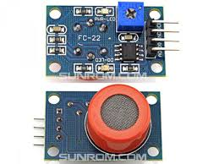

**3.LIQUID CRYSTAL DISPLAY**

##### Liquid crystal display screen is the electronic display module and find a wide ranges of applications. A 16*2 LCD display is very basic module and it is very commonly use in various devices and circuit. These modules are preferred to seven segments and other multi segments LEDs. The reason being: LCDs are economical; easily programmable; have no limitation of displaying special and even custom characters (unlike in 7 segments), animations and so on. A 16*2 LCD means it can display 16 characters per line and there are 2 such lines. In this LCD each character is displayed in 5*7 pixel matrix. This LCD



## ****Programming Guide****

The Arduino sketch imports Servo.h for controlling servo motor and LiquidCrystal.h for LCD display. An object of LCD type is instantiated and assigned controller pins. Variables denoting LED and pin connection of MQ-3 sensor are declared and assigned controller pins. An object of servo type is declared and variables to store sensor value and servo angle are declared.

 #include <Servo.h>

#include <LiquidCrystal.h>

LiquidCrystal lcd(2, 3, 4, 5, 6, 7);

int ledPin = 12;

int sensorPin = A1;

Servo myservo;

int pos = 0;

int value;

The setup() function is declared which runs for once after the controller is powered on. In the function, the baud rate for serial communication with the LCD module is set to 9600 baud per second. The LCD object is initialized to 16 by 2 character LCD mode and the pin connecting LED is set to digital output using pinMode() function. The servo motor is rotated to 10-degree

angle by default.

* SOURCE CODE

#include <Servo.h>

#include <LiquidCrystal.h>

LiquidCrystal lcd(2, 3, 4, 5, 6, 7);

int ledPin = 12;

int sensorPin = A1;

Servo myservo;

int pos = 0;

int value;

void setup()

{

Serial.begin(9600);

lcd.begin(16,2);

pinMode(ledPin,OUTPUT);

myservo.attach(10);

}

void loop()

{

int Value = analogRead(sensorPin);

value = analogRead(A1);

lcd.print("Alcohollevel:");

lcd.println(value);

Serial.println(value);

if (Value > 500)

{

digitalWrite(ledPin,HIGH);

lcd.setCursor(0, 2);

lcd.print("Alert....!!!");

Serial.print ("Alert");

myservo.write(100);

}

else

{

digitalWrite(ledPin,LOW);

lcd.setCursor(0, 2);

lcd.print("Normal... :)");

Serial.print("Normal");

myservo.write(0);

}

delay(1000);

lcd.clear();

}

* **ADVANTAGES**

**1. To prevent accident due to drunk and driving.**

**2. Easy and efficient to test the alcohol content in the body.**

**3. Quick and accurate results.**

**4. Helpful for police and provides and automatic safety systems for cars and other vehicles as well.**

* **LIMITATION**

**Other things like sanitizers , car freshners and perfumes contains alcohol which can effect sensor.**

* **APPLICATIONS**

1. **“Alcohol detector project” can be used in the various vehicles for**

**detecting whether the driver as consumed alcohol or not.**

1. **This project can also be used in various companies or organizations to**

**detect alcohol consumptions of employees.**

**Empathy canvas**

To define any user’s centric problem we need to know the user properly. That was what this canvas was all about.

We thought about so many people but wanted to go for some people that mostly remain untouched by technology but are larger in number.

They cover a large mass but are least touched with technology.

**+Story boarding**

Most interesting part was the ‘Story Boards’ which can be called the board of emotion understanding the problem of society is one of the biggest challenges for engineering student as till now they were making projects on imaginary ideas.

It helped us understanding that when we build anything for anyone, the purpose and emotion behind that are equally important.

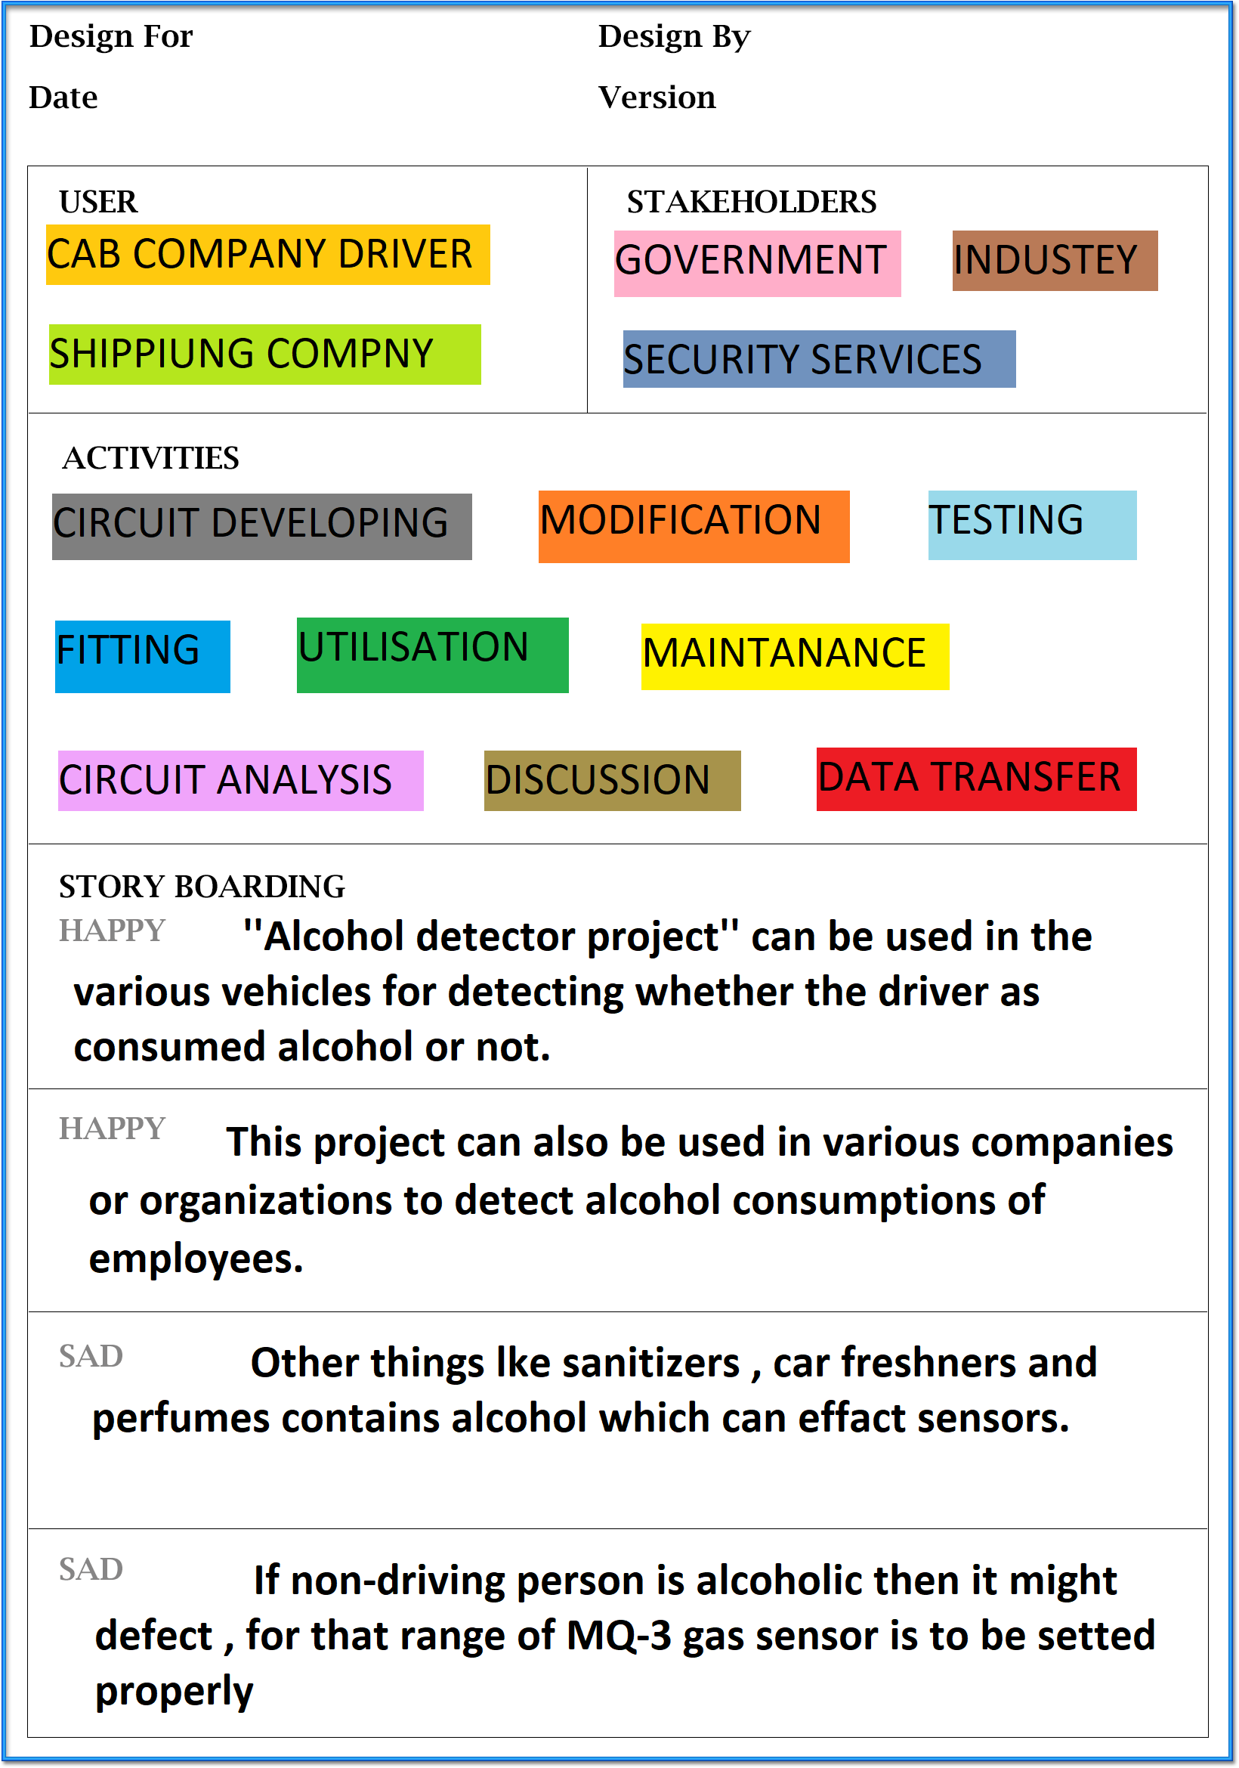

**AEIOU Canvas**

Activity Canvas was the portion, in which we had to include the activities that people carry out in their life. We tried to note down all the security and safety activities that goes on in the background.

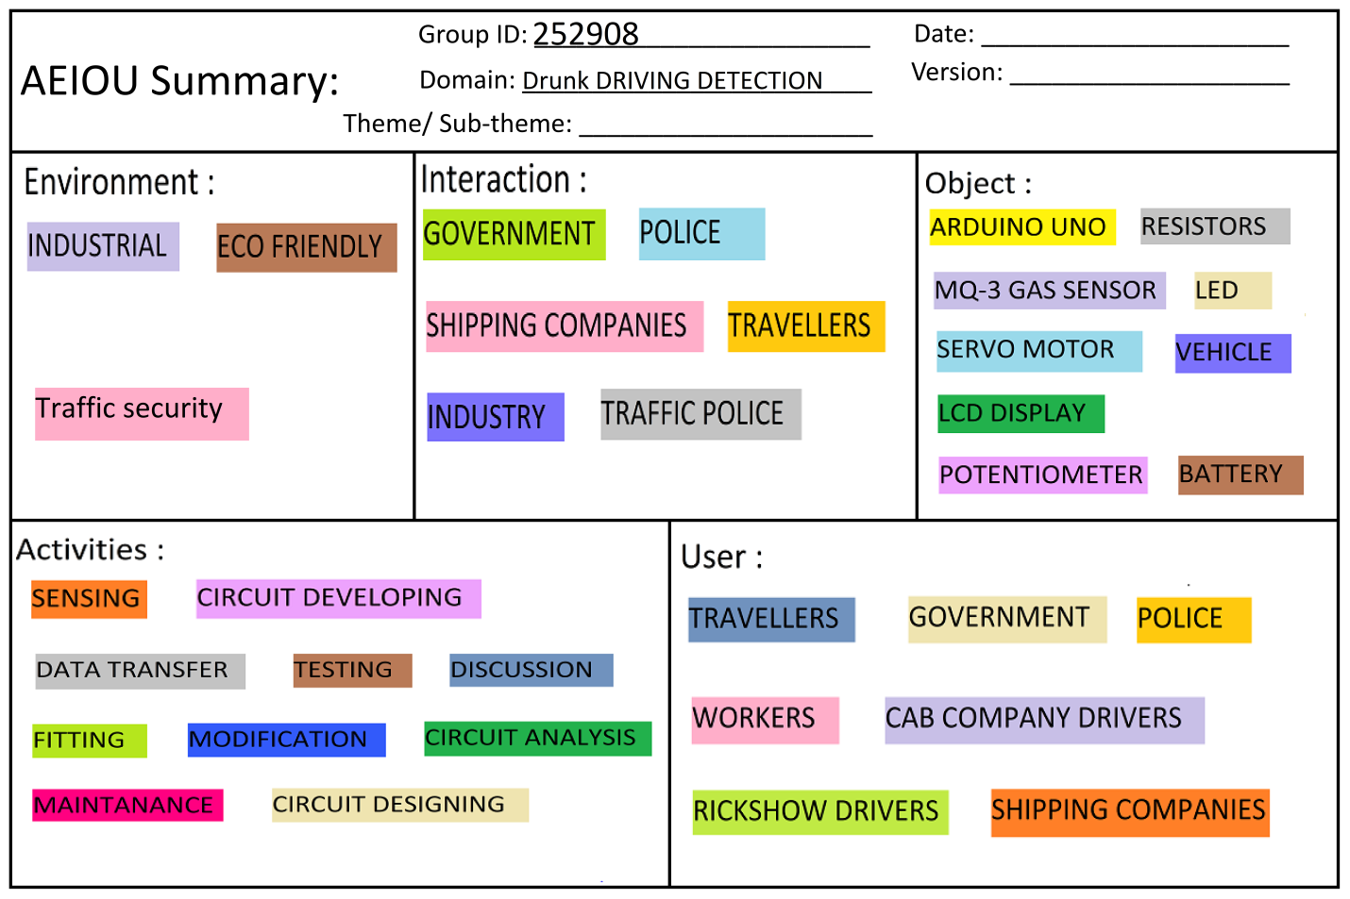

**Mind map**

This canvas is summarization canvas for all the other canvases we used during the designing process. We included users in our canvas users are the persons who use this application or who are connected with this sector. Alsowe include problems and solutions in this canvas. This canvas is very useful to develop application.

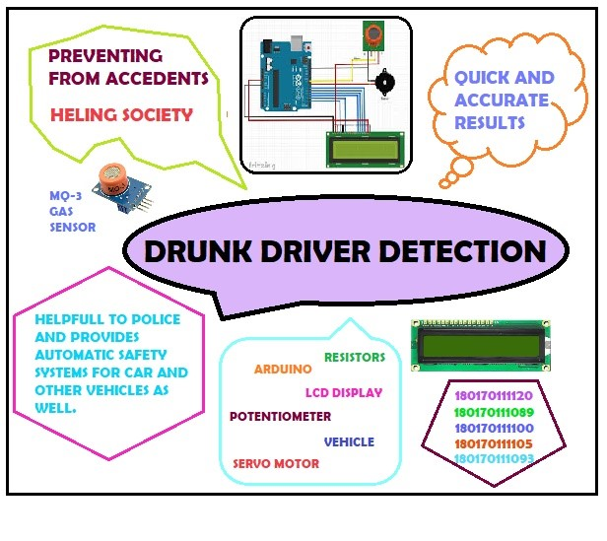

**Ideation Canvas**

In ideation canvas we started with people. people includes that who can be connected with our project. There are various people who are connected with our project like people with hand disability,Medicalsector,Automation systems Then we listed out that what activity every segment of people does. Then we thought about situation/context/location and finally for possible solutions.

. 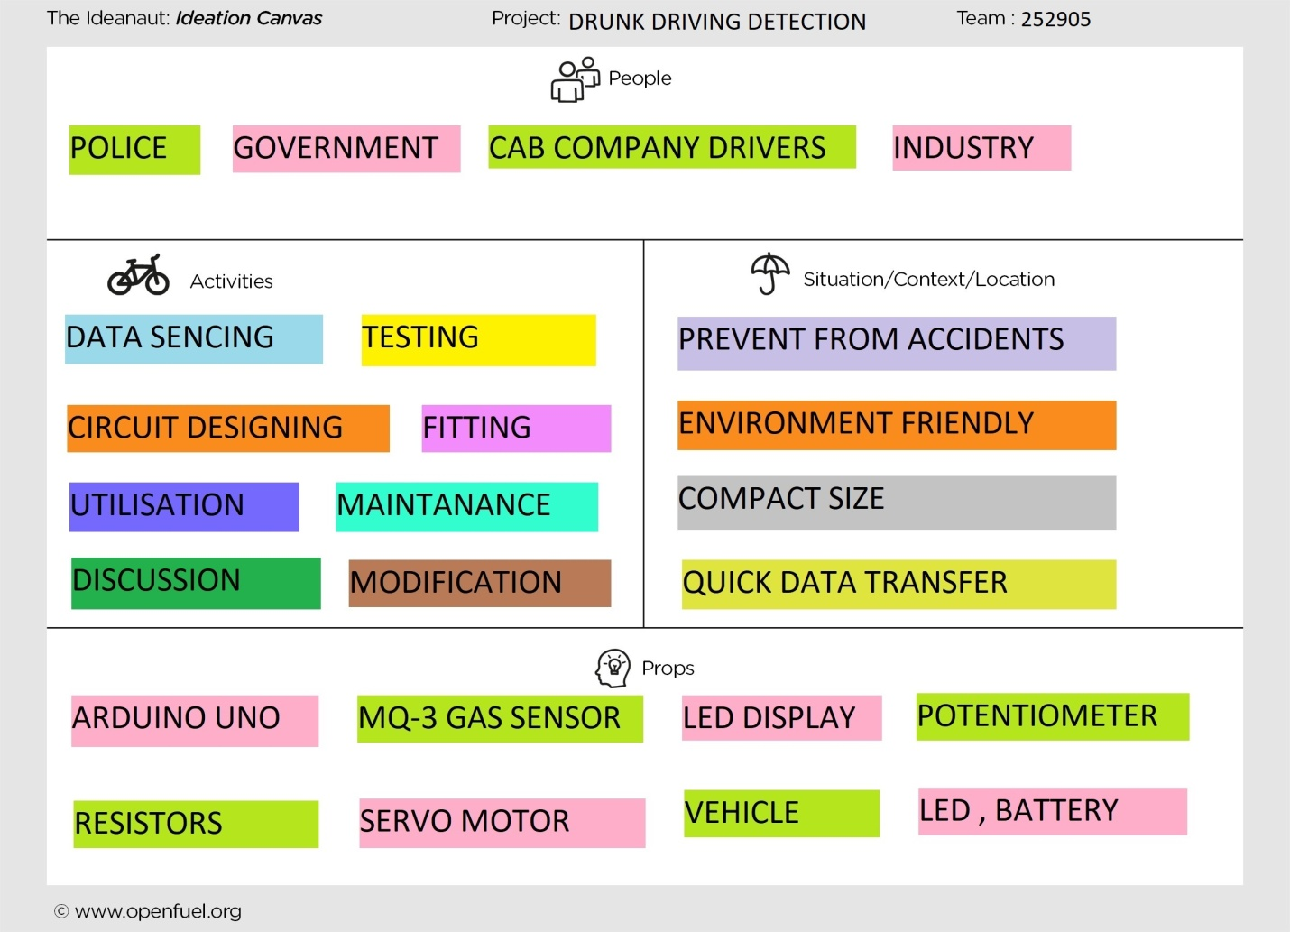

**Product Development Canvas**

In this canvas we mentioned purpose of our product, functions, features and products experience.

For this purpose, we defined some functions that our product must do. These included, for each of the function that our product fulfills, also there is some features of our product.

The components which are required for our product is also mentioned.

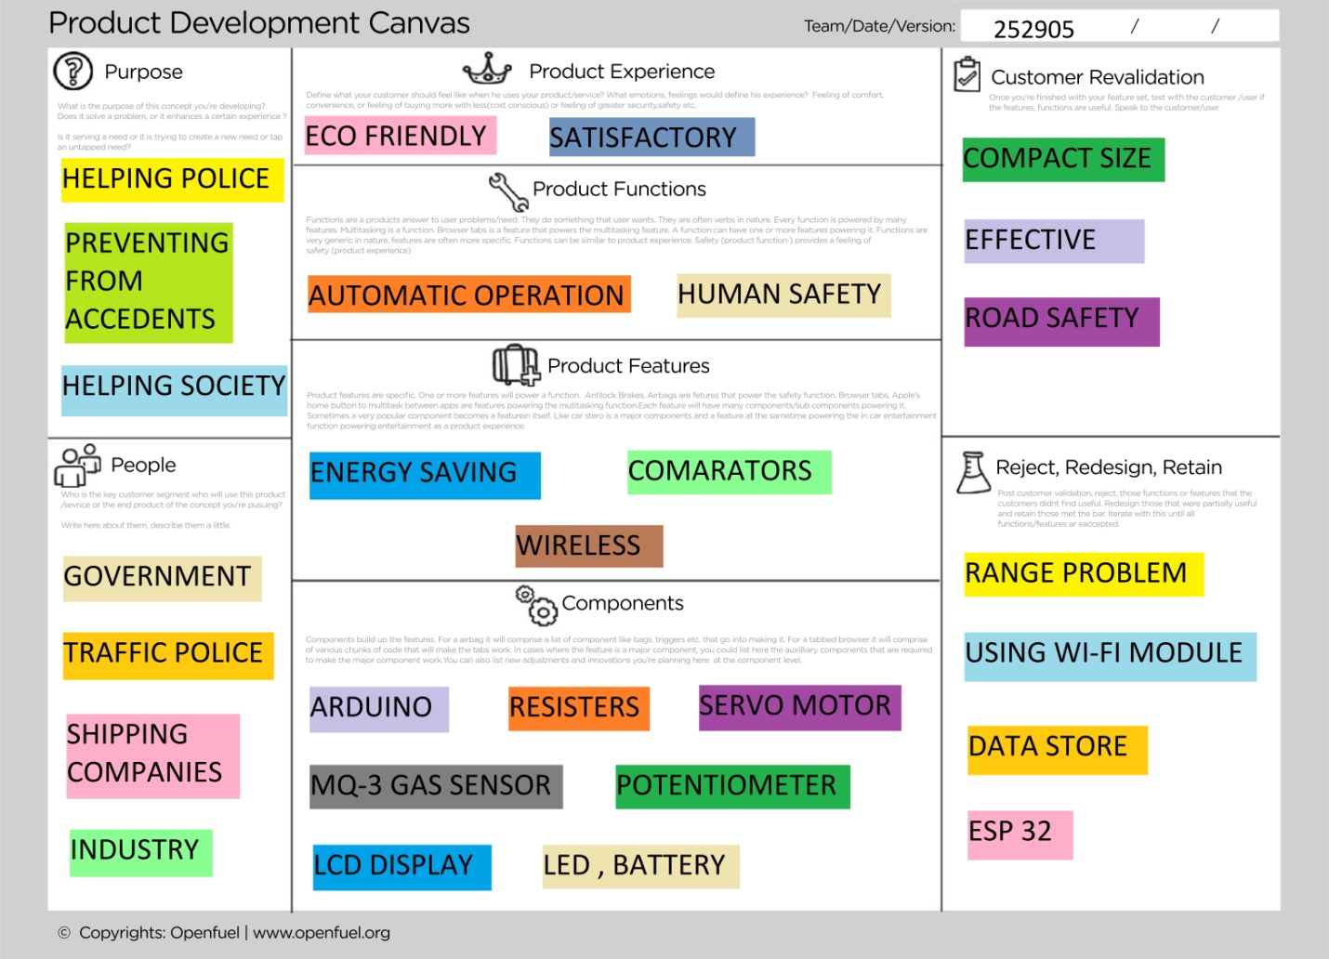

**Conclusion**

**We have provided a very effective solution to develop an intelligent system for vehicles for alcohol detection whose core is Arduino. Since sensor has fine sensitivity range around 2 meters, it can suit to any vehicle and can easily be hidden from the suspects. The whole system has also an advantage of small volume and more reliability. As the growing public perception is that vehicle safety is more important, advances in public safety is gaining acceptance than in the past. Future scope of this system is to control the accidents causes due to alcohol consumption. This system improves the safety of human being. And hence providing the effective development in the automobile industry regarding to reduce the accidents cause due to alcohol.**